Part I. Multiple choice questions.

1 | 2 | 3 | 4 | 5
A | B | C | B | D
6 | 7 | 8 | 9 | 10
D | D | B | A | B

Part II. Short questions.
11. DDA has the following problems: Accumulation of round-off errors can make the pixelated line drift away from what was intended; The rounding operations and floating point arithmetic involved are time consuming. The Bresenham line algorithm has the following advantages: An fast incremental algorithm; Uses only integer calculations.

12. Because they are ﬂat, simple, cheap to process and easy to interpolate across.

13. In some cases where faces and polygons are overlapping, this algorithm will fail. An example of this situation is shown in the following figure.
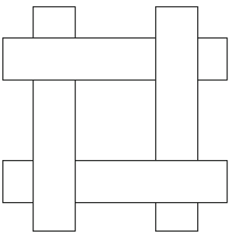
14. 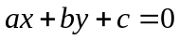, where 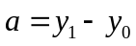, 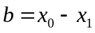, 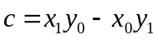
Part III. Long questions.
15.
I. A rotates the object around the Y axis. (By 45 degrees. In a right-handed system, counter-clockwise looking out along the Y axis. Students are not expected to specify the angle or the direction.)
II. B translates the object by 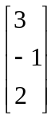.
III. C translates the object by , then rotates it around the Y axis.
IV. D rotates the object around by translating by B⁻¹, rotating around the Y axis at the origin, then translating back by B.

- Three transformations should be performed in the following sequence:
- Translate using the vector 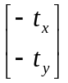. This is represented by M₁ where
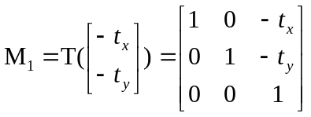
- Rotate through the angle θ . This is represented by M₂ where
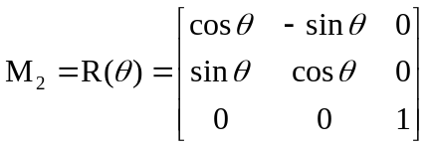
- Translate back using the vector 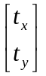. This is represented by M₃ where
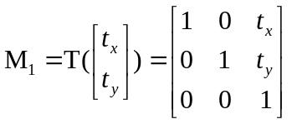
Then, the overall transformation matrix is expressed as
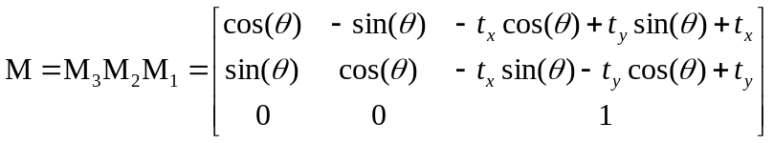
17. In the midpoint algorithm, the equation of the line spanning from 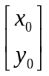to 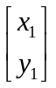is expressed as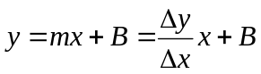, where m is the slope; 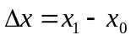; 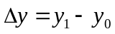; and B is the y-intercept. The implicit form of the line equation can be written as , where , , . Now, the midpoint 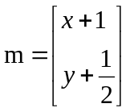between p₁ 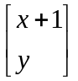and p₂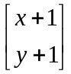is applied to the implicit equation to get 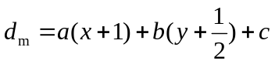.
There are three possibilities for d_{m}:
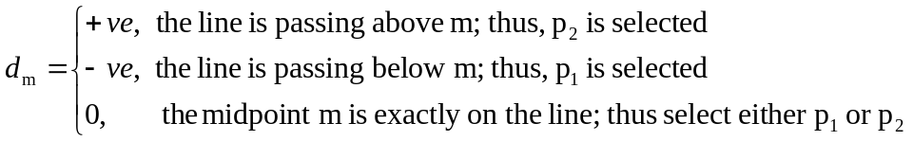
Choosing the pixel in the next column depends on whether p₁ or p₂ has been chosen. Assume that p₁ is selected. The midpoint 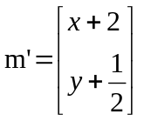between 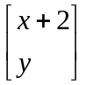and 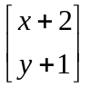is applied to the implicit equation to get
On the other hand, if p₂ is selected, The midpoint 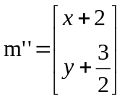between and 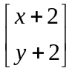is applied to the implicit equation to get
This means that the subsequent sign of d_{m} can be obtained by incrementing it by either 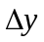if p₁ is selected or 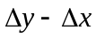if p₂ is selected. An initial value for d_{m} can be obtained using the start point and the implicit equation. So, 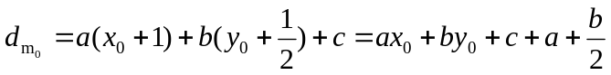, where 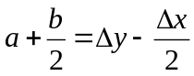is the initial estimate of d_{m}.

18.
Algorithm 1 Outcode calculation algorithm
Input: x, y, xmin, xmax, ymin, ymax
Output: outcode
1: outcode = 0000
2: if (y > ymax) then
3: outcode = outcode OR 1000
4: else if (y < ymin) then
5: outcode = outcode OR 0100
6: end if
7: if (x > xmax) then
8: outcode = outcode OR 0010
9: else if (x < xmin) then
10: outcode = outcode OR 0001
11: end if
12: return outcode
end

Algorithm2 Cohen-Sutherland clipping algorithm
Input: x0, y0, x1, y1, xmin, ymin, xmax, ymax
1: outcode0 = Call Algorithm1 for x0, y0
2: outcode1 = Call Algorithm1 for x1, y1
3: done = FALSE
4: in = FALSE
5:
6: while (done = FALSE) do
7: if (outcode0 OR outcode1 = 0000) then
8: done = TRUE
9: in = TRUE
10: else if (outcode0 AND outcode1 != 0000) then
11: done = TRUE
12: else
13: m = (y1 − y0)/(x1 − x0)
14: if (outcode0 !=0000) then
15: outcode = outcode0
16: else
17: outcode = outcode1
18: end if
19:
20: if (outcode AND 1000 != 0000) then
21: x = x0 + (ymax − y0)/m
22: y = ymax
23: else if (outcode AND 0100 != 0000) then
24: x = x0 + (ymin − y0)/m
25: y = ymin
26: else if (outcode AND 0010 != 0000) then
27: x = xmax
28: y = y0 + m ( xmax − x0 )
29: else
30: x = xmin
31: y = y0 + m ( xmin − x0 )
32: end if
33:
34: if (outcode = outcode0) then
35: x0 = x
36: y0 = y
37: outcode0 = Call Algorithm1 for x0 , y0
38: else
39: x1 = x
40: y1 = y
41: outcode1 = Call Algorithm1 for x1 , y1
42: end if
43: end if
44: end while
45:
46: if (in = TRUE) then
47: draw line x0, y0, x1, y1
48: end if
end

19.
Working with line ab:
- Get the outcodes for endpoints a and b:
outcodea=0000, outcodeb=0000.
- Perform a bitwise-ORing operation between outcodea and outcodeb:
outcodea OR outcodeb = 0000 OR 0000 = 0000
Since the result of the bitwise-ORing operation is 0000, both endpoints are in the clip rectangle.
Therefore, the line ab is trivially accepted.

Working with line cd:
(1) Get the outcodes for the endpoints c and d:
outcodec = 0000 ,
outcoded = 0100 .
(2)
a. Perform a bitwise-ORing operation between outcodec and outcoded:
outcodec OR outcoded = 0000 OR 0100 = 0100 .
b. Since the bitwise-ORing operation results in a value that is not 0000, perform a bitwise-ANDing operation between outcodec and outcoded:
outcodec AND outcoded = 0000 AND 0100 = 0000 .
c.
i. Since the bitwise-ANDing operation results in 0000, get the slope m of the line, which is computed as m =(y_{d} − y_{c})/(x_{d} − x_{c})=(39 − 101)/(233 − 150)=-62/83=−0 . 7470 .
ii. Get the outpoint which has the outcode that is not equal to 0000 as outcoded = 0100 .
iii. Since outcoded AND 0100 = 0100, then the line extending from the outpoint (i.e., d) to c intersects the bottom edge of the clip rectangle. Split the line at the intersection point between the line and the clip rectangle. Utilizing the value of m, the intersection point is obtained as
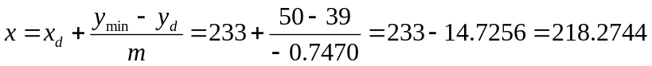
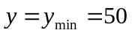
In other words, the intersection point is 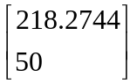. Let us call this point g.
iv. Remove the part between d and g. The outcode for the intersection point now is outcodeg = 0000.
v. The line to be tested now is extending from c to g. The outcode for each of its endpoints is 0000.
- The procedure is applied again to line cg. Hence, line cg is trivially accepted.

Working with line ef:
- Get the outcodes for the endpoints:
outcodee=0101, outcodef=0101
(2)
a. Perform a bitwise-ORing operation between outcodee and outcodef:
outcodee OR outcodef = 0101 OR 0101 = 0101 .
b. Since the bitwise-ORing operation results in a value that is not 0000, perform a bitwise-ANDing operation between outcodee and outcodef:
outcodee AND outcodef = 0101 AND 0101 = 0101 .
Since the result of the bitwise-ORing operation is not 0000, the line ef is trivially rejected.

20.
(1) Compute the intersections D and E between the scan line y = 2 and AC, BC respectively.
D=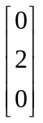, E=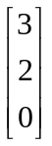
- Get the intensity at D and E:
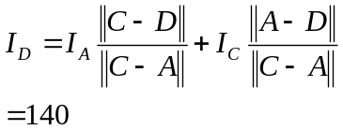
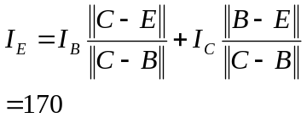
- Get the intensity at P:
